Exp No: 24
MODELING CLOCK-DRIVEN CONCURRENT PROCESSES USING SC_THREAD AND WAIT() IN SYSTEMC
AIM:
To understand and implement a clock-driven process using: • sc_clock • SC_THREAD • wait() • Event sensitivity (positive edge trigger) in SystemC.
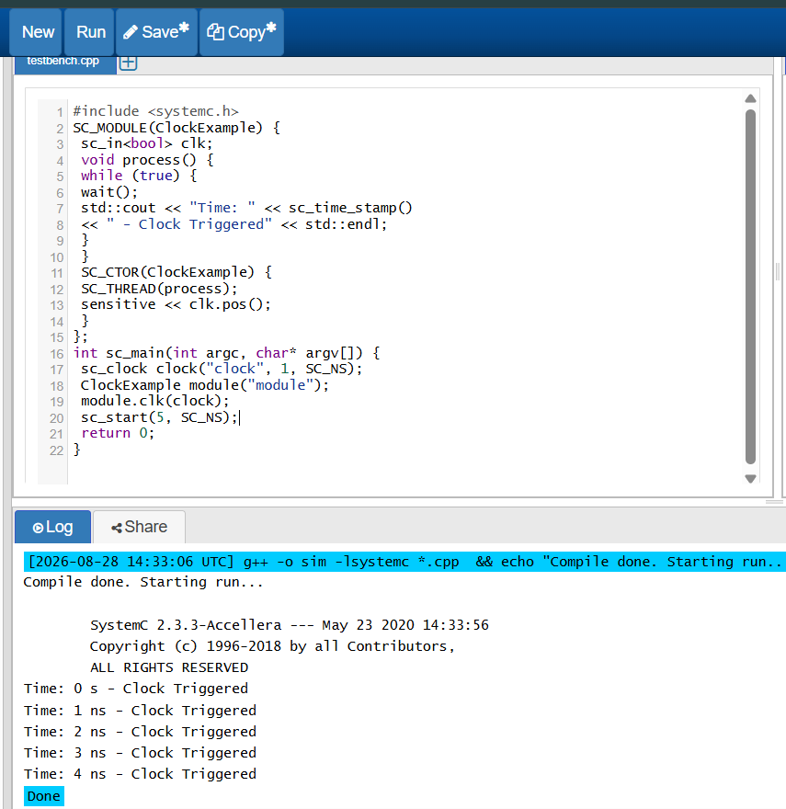

RESULT: Thus, the clock-driven process using SC_THREAD and wait() was successfully implemented and verified in SystemC

